**OBJECT ORIENTED PROGRAMMING**

**CSL-120  
  
BSCS 2B – Spring 2021**

**HOSTEL MANAGEMENT SYSTEM**



**DEPARTMENT OF COMPUTER SCIENCE**

**BAHRIA UNIVERSITY, KARACHI CAMPUS**

**SUBMITTED TO:**

MISS SALAS AKBAR

**SUBMITTED BY:**

SHAHEER IMRAN

(02-134202-049)

YUSRA ATHAR SYED

(02-134202-057)

DARAKSHAN AHMED

(02-134202-036)

**COURSE INSTRUCTOR:**

MISS SAMEENA JAVAID

**LAB INSTRUCTOR:**

MISS SALAS AKBAR

**CLASS:**

BSCS-2B SPRING 2021

**Table of Contents**

ACKNOWLEDGEMENT 3

INTRODUCTION 4

MOTIVATION 4

UML: 6

PROJECT DESIGN: 7

DATABASE DIAGRAM: 15

FLOWCHART: 16

RESULT/ SCREENSHOTS OF CODE AND OUTPUT: 17

HARDWARE SPECIFICATION: 49

SOFTWARE SPECIFICATION: 49

CONCLUSION 49

REFERENCES 49

# **ACKNOWLEDGEMENT**

First, we would like to express gratitude to our supervisor, **MA’AM SALAS AKBER** for her demonstration of guidance, giving useful advice, conceptualize the project which enabled us to have clear understanding of our project. We would like to thank and appreciate people who have willingly helped us out with their abilities.

# **INTRODUCTION**

This system is designed in favor of the hostel management which helps them to save the records of the students about their rooms and other things. It helps them from the manual work from which it is very difficult to find the record of the students and the mess bills of the students, and the information of about those ones who had left the hostel. All the hostels at present are managed manually by the hostel office. The Registration form verification to the different data processing is done manually. Thus, there are a lot of repetitions which can be easily avoided. And hence there is a lot of strain on the person who are running the hostel and software’s are not usually used in this context. This project deals with the problems on managing a hostel and avoids the problems which occur when carried manually Identification of the drawbacks of the existing system leads to the designing of computerized system that will be compatible to the existing system with the system which is more user friendly. We can improve the efficiency of the system, thus overcome the drawbacks of the existing system. We design this system of the hostel management especially for the college hostel, through this they cannot require so efficient person to handle and calculate the things. This system automatically calculates all the bills and issued the notifications for those students who are against some rules.

# **MOTIVATION**

This software product the hostel management to improve their services for all the students of the hostel. This also reduce the manual work of the persons in admin penal and the bundle of registers that were search when to find the information of a previous student, because through this system you can store the data of those students who had left the hostel. Through this you can check the personal profile of all the current students within few minutes the data base of the system will help you to check a particular one. The system will help you to check the mess bills of every student and the student’s hostel dues. The students of the hostel will be recognized from the ID number allocated at the room rental time. In the last this system will improve the management work in the hostel. To automate each activity of the manual system, which increases its throughput.

# **UML:**

## 

# **PROJECT DESIGN:**

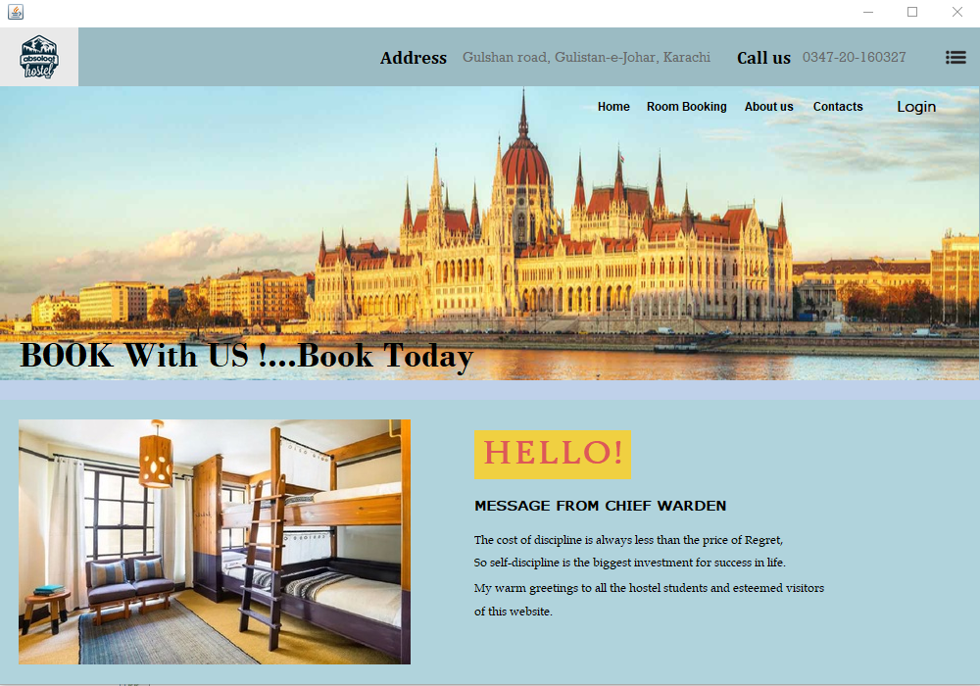

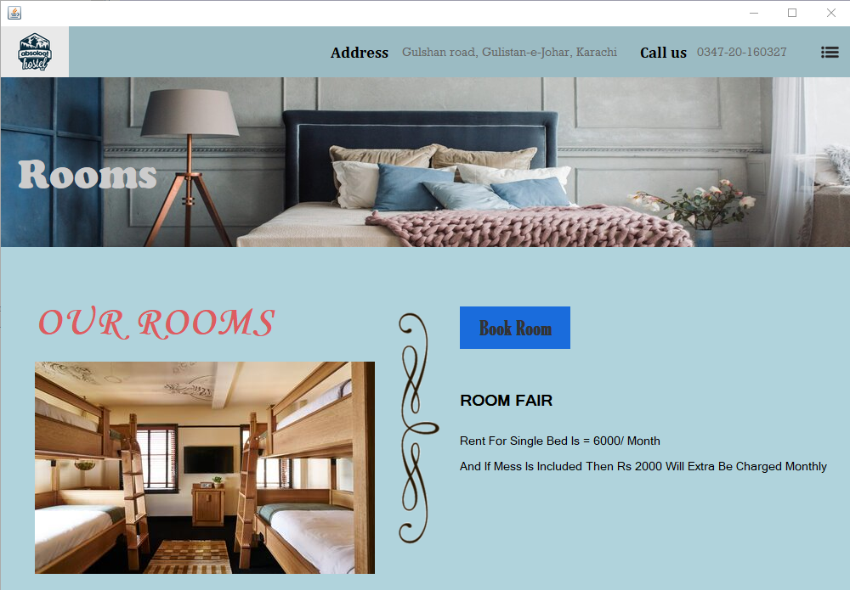

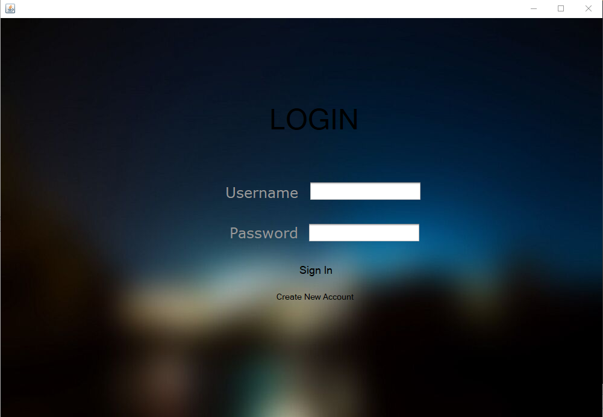

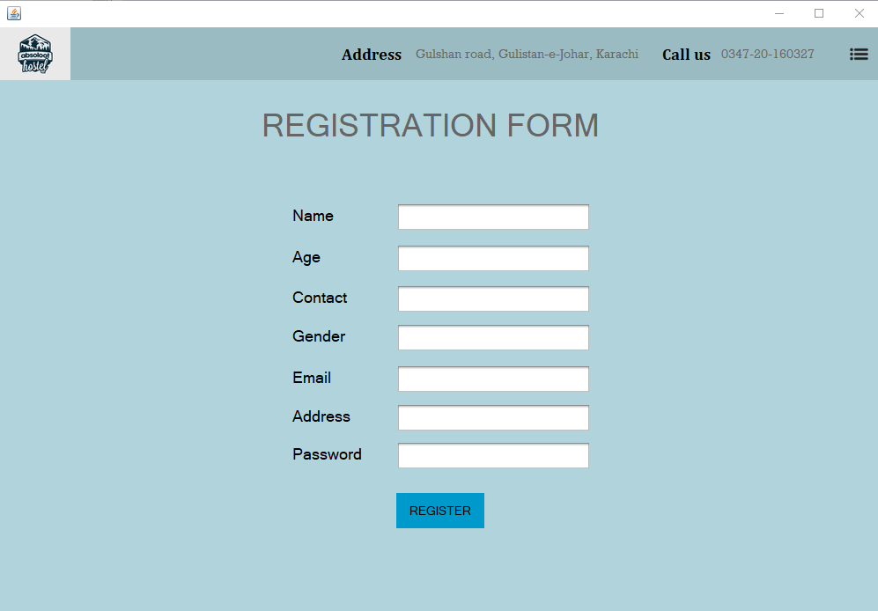

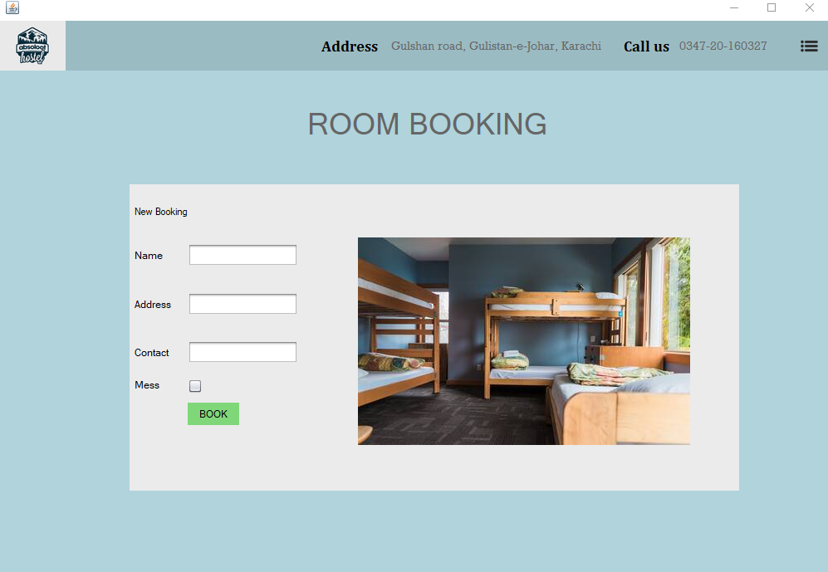

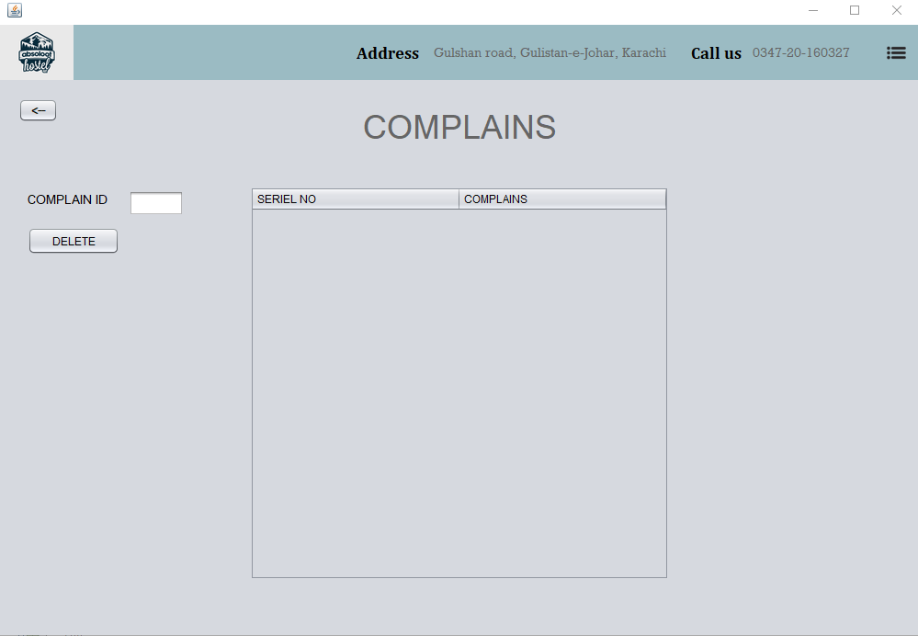

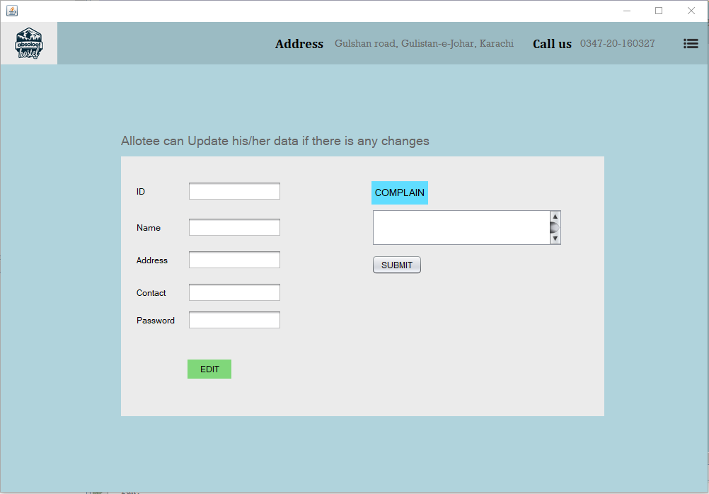

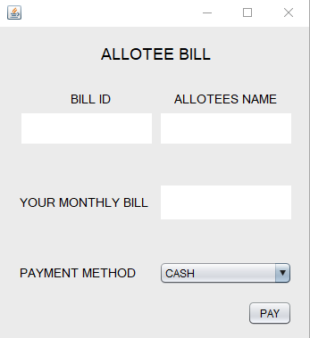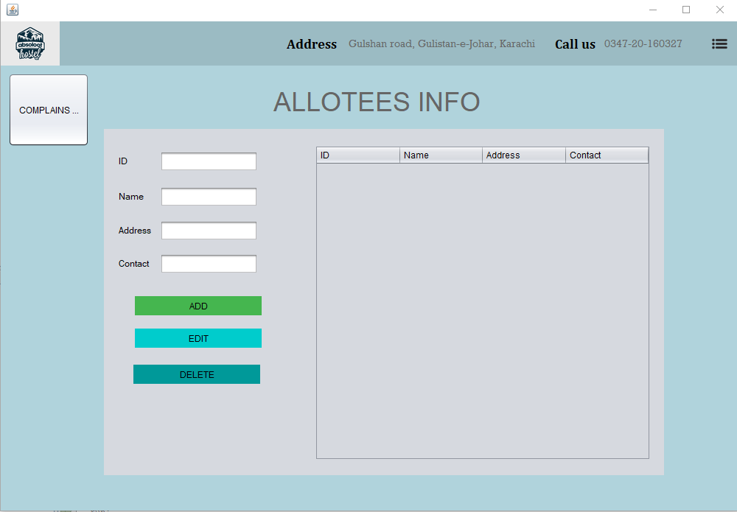

# **DATABASE DIAGRAM:**

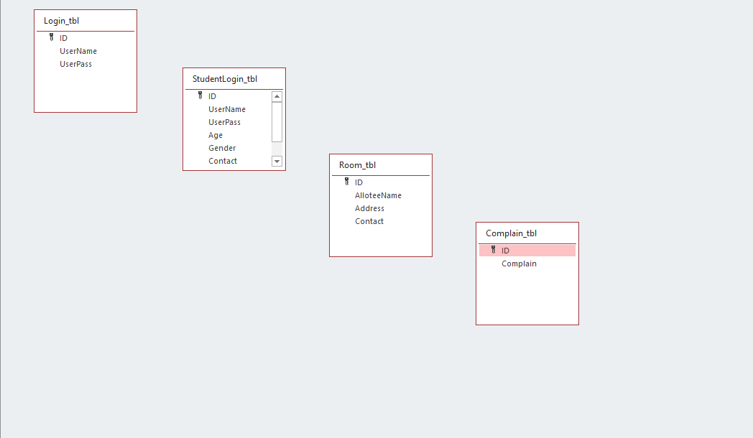

# **FLOWCHART:**

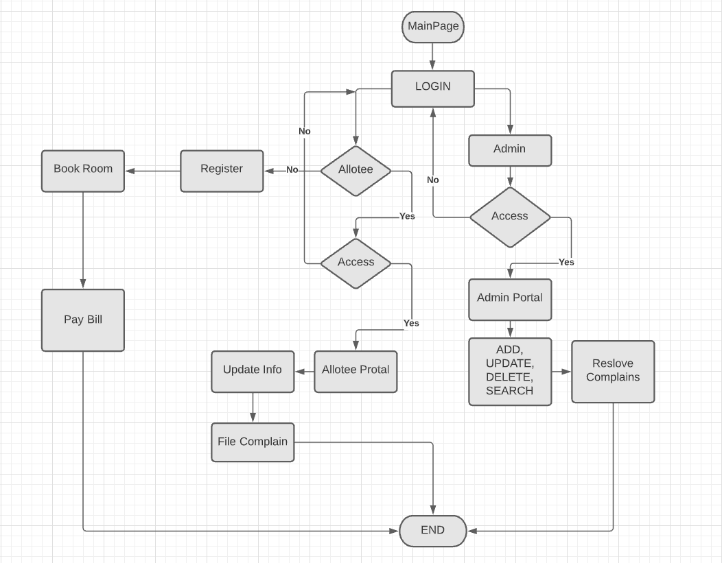

# **RESULT/ SCREENSHOTS OF CODE AND OUTPUT:**

**CONNECTION TO DATABASE CLASS**

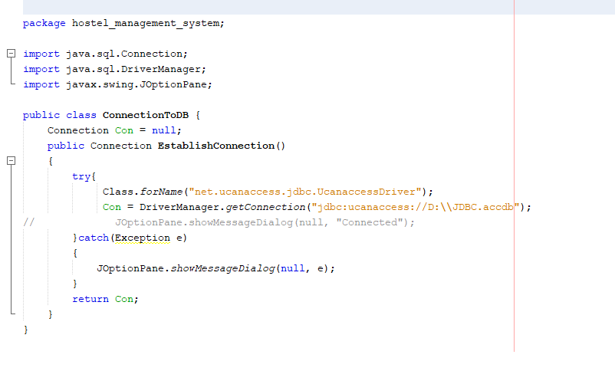

**LOGIN CLASS**

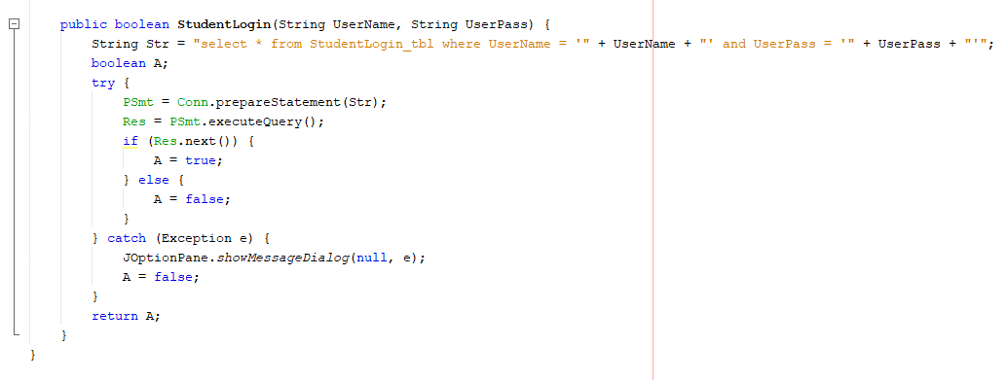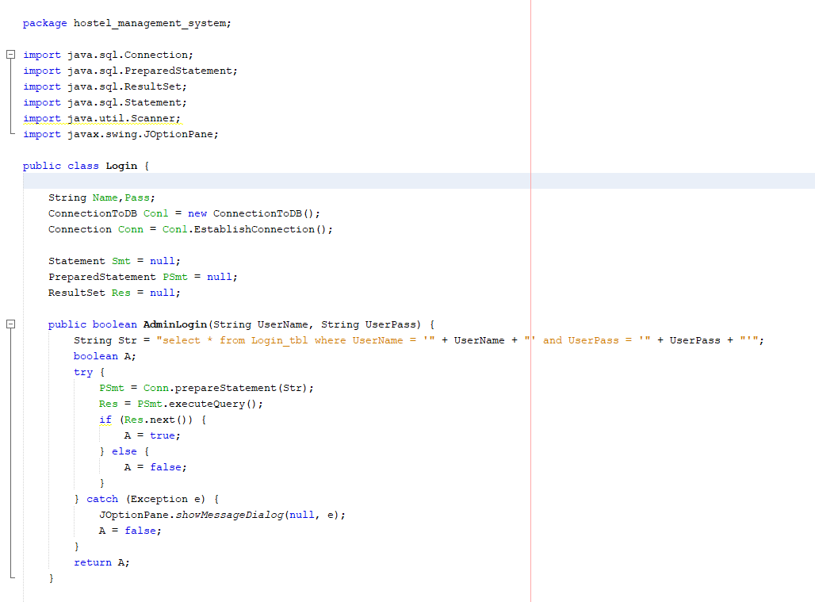

**HOSTEL CLASS**

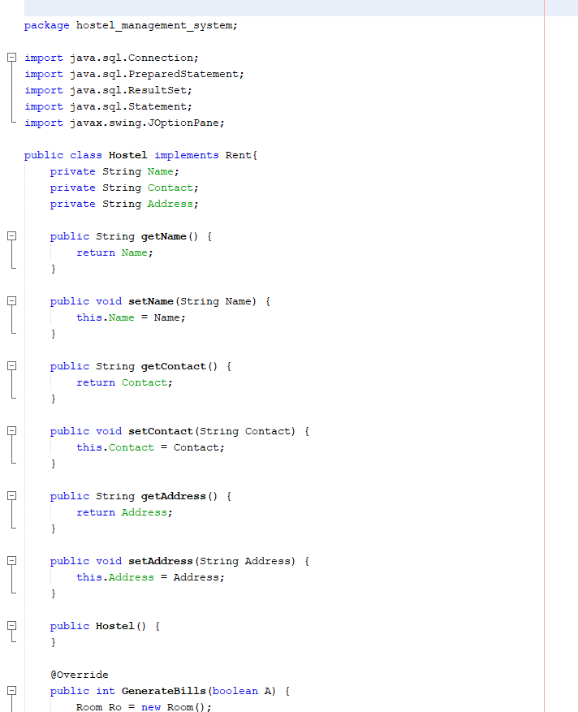

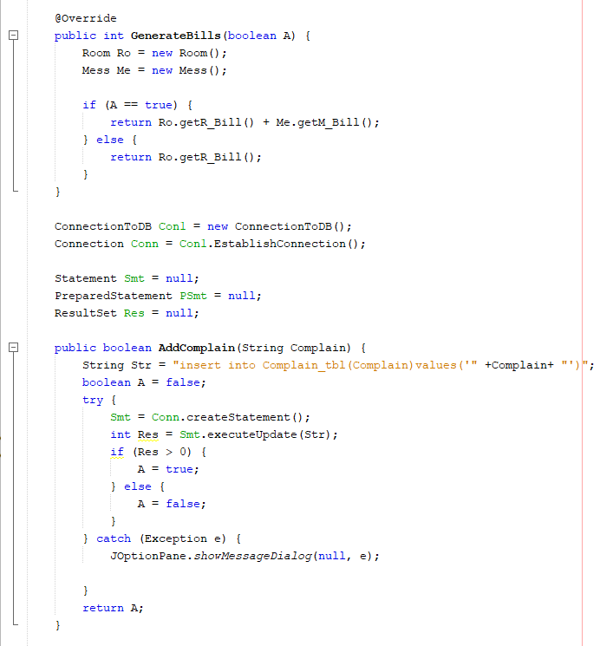

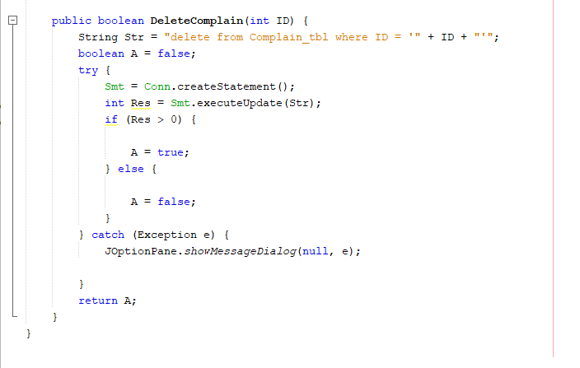

**ALLOTEE CLASS**

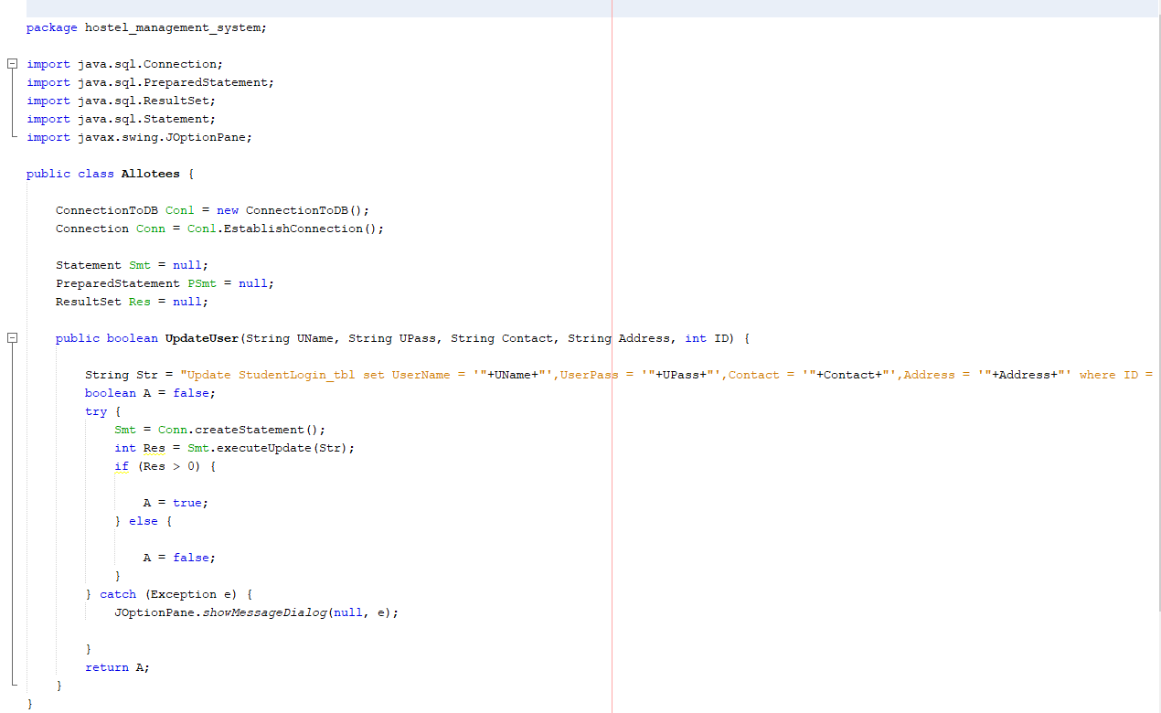

**REGISTRATION CLASS**

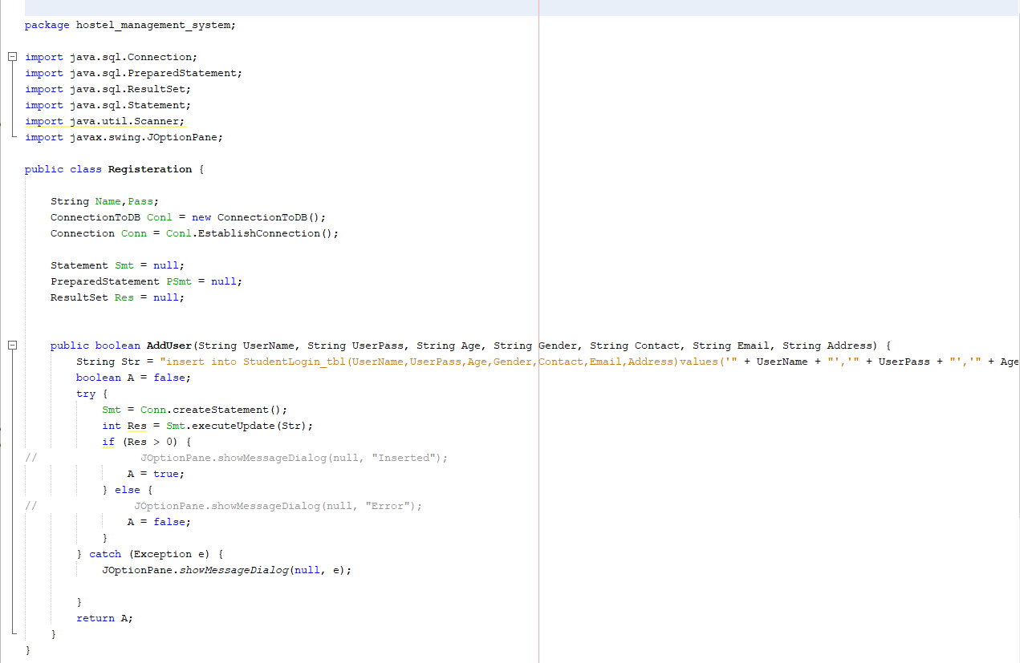

**RENT INTERFACE**

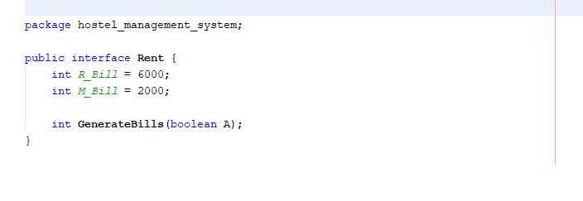

**MESS CLASS**

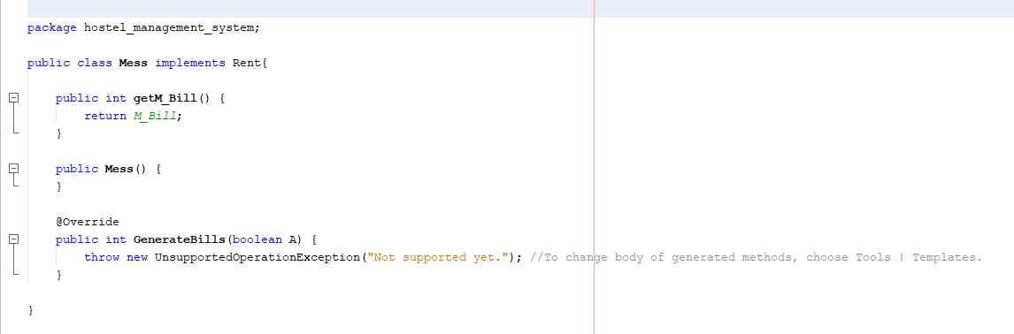

**ROOM CLASS**

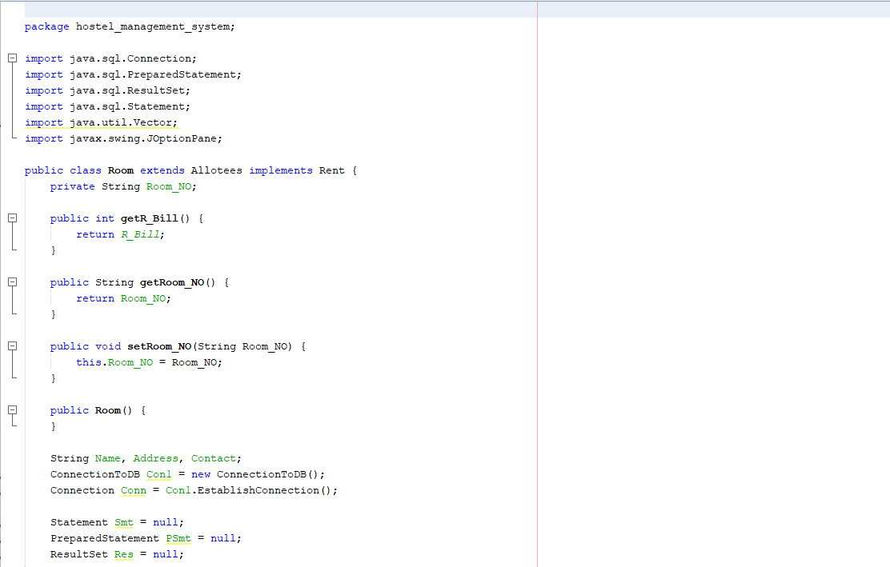

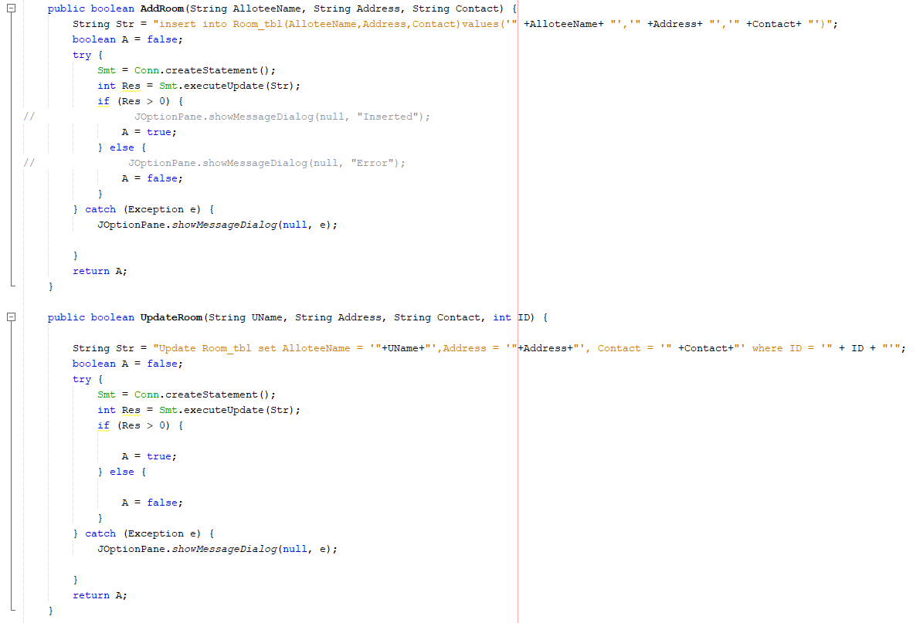

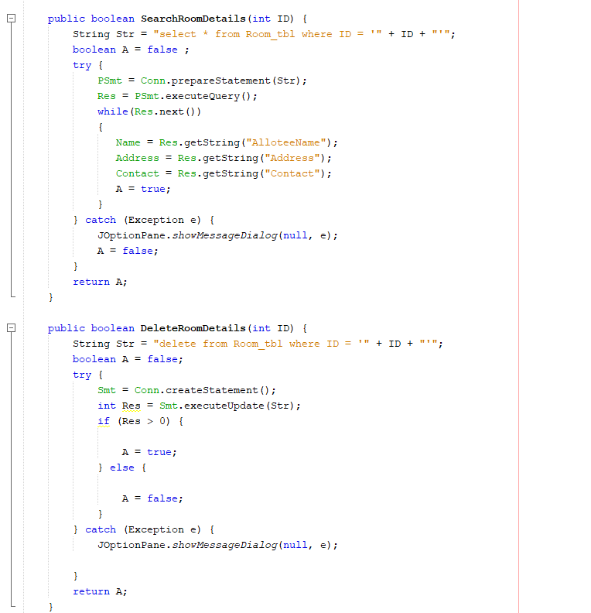

**JFRAME BUTTONS CODE**

**MAINPAGE BUTTONS:**

**LOGIN BUTTON:**

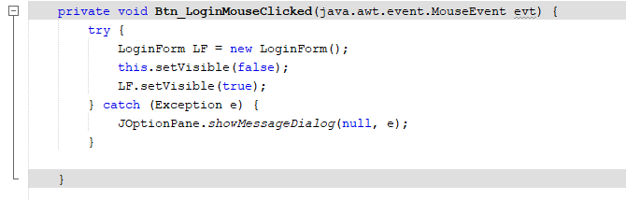

**ROOM BOOKING BUTTON:**

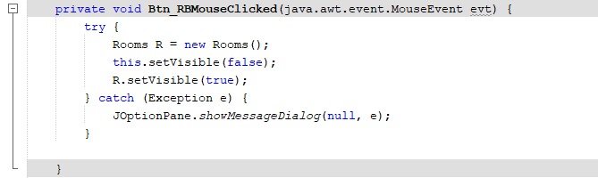

**LOGIN FORM BUTTONS:**

**SIGN-IN BUTTON:**

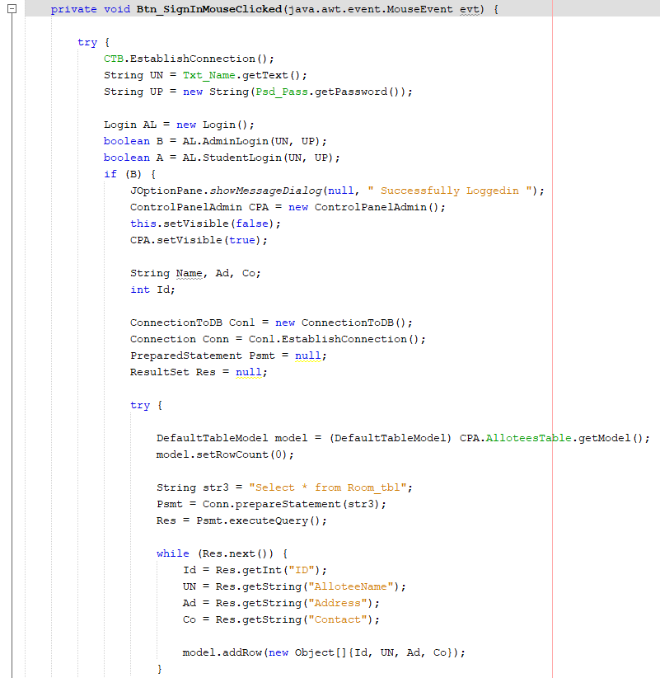

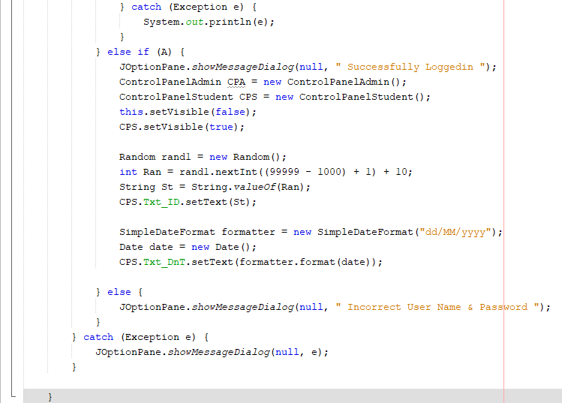

**CREATE NEW ACCOUNT BUTTON:**

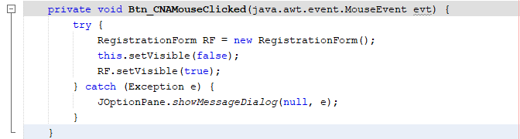

**REGISTRATION FORM BUTTONS:**

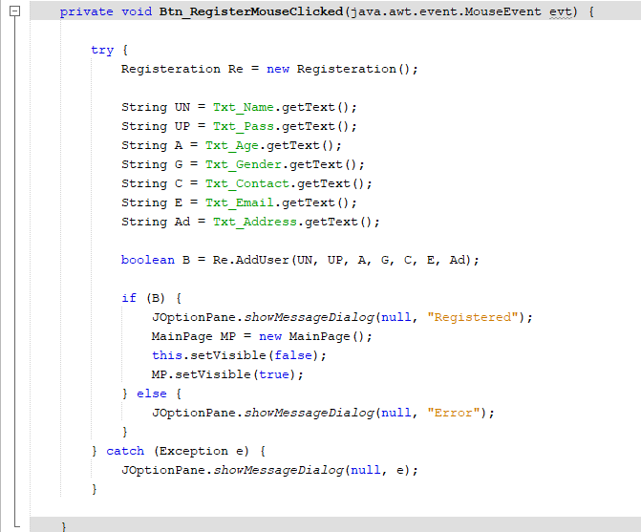**REGISTER BUTTON:**

**ROOMS FORM BUTTONS:**

**BOOK ROOM BUTTON:**

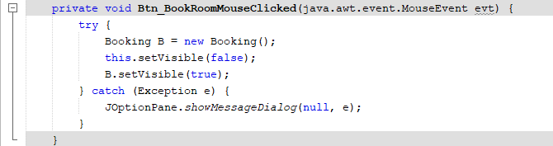

**BOOKING FORM BUTTONS:**

**BOOK BUTTON:**

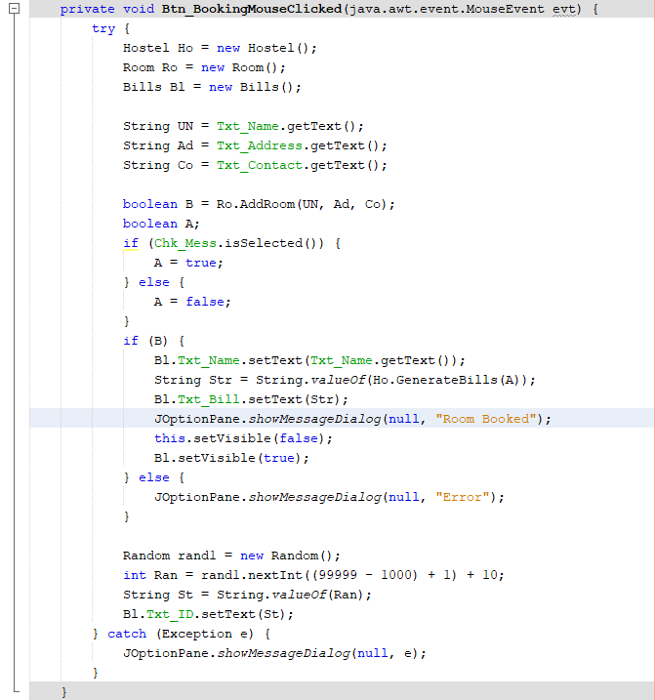

**BILLS FORM BUTTONS:**

**PAY BUTTON:**

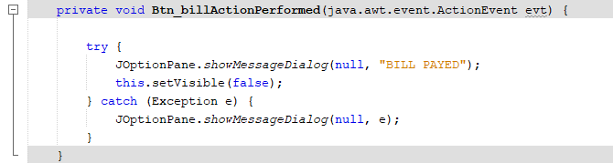

**CONTROL PANNEL ADMIN FORM BUTTONS:**

**ALLOTEE TABLE BUTTON:**

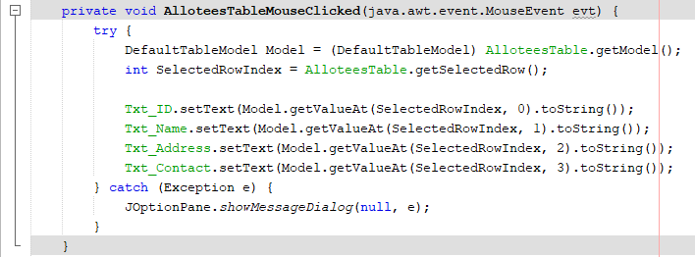

**ADD BUTTON:**

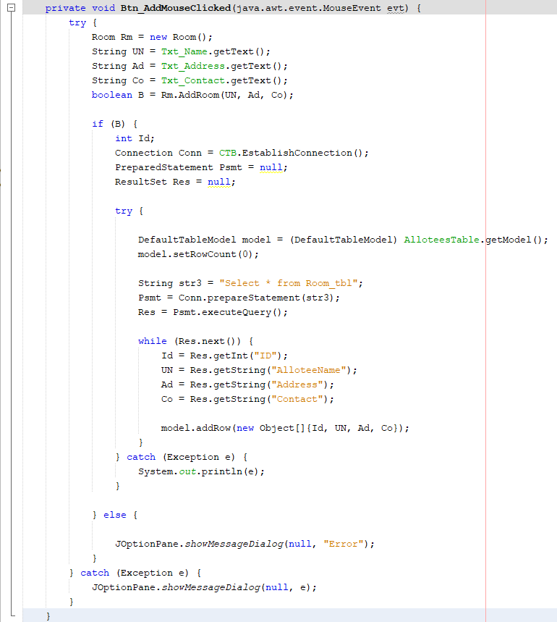

**EDIT BUTTON:**

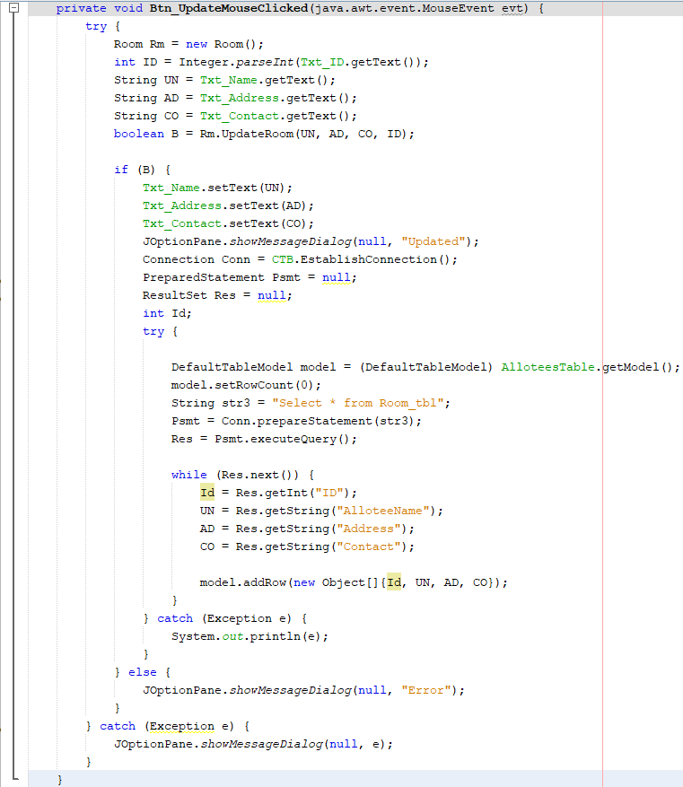

**DELETE BUTTON:**

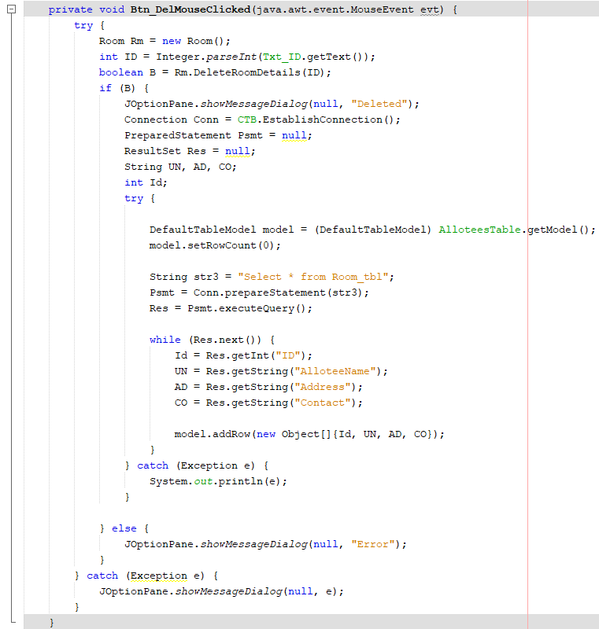

**COMPLAIN BUTTON:**

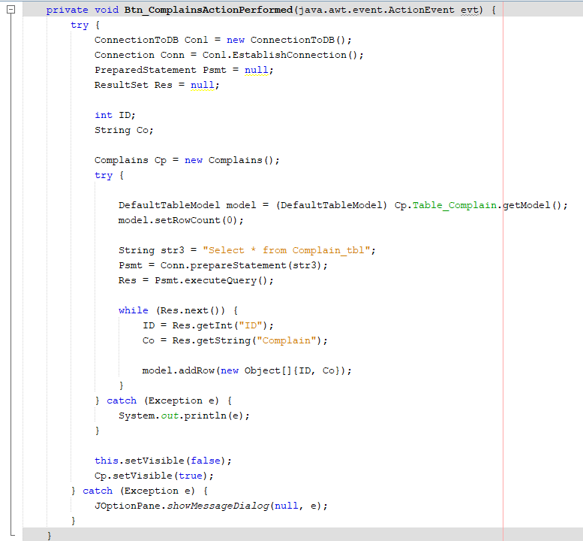

**COMPLAIN FORM BUTTONS:**

**COMPLAIN TABLE BUTTON:**

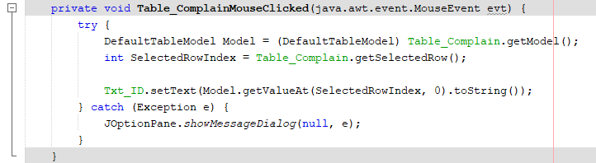

**DELETE BUTTON:**

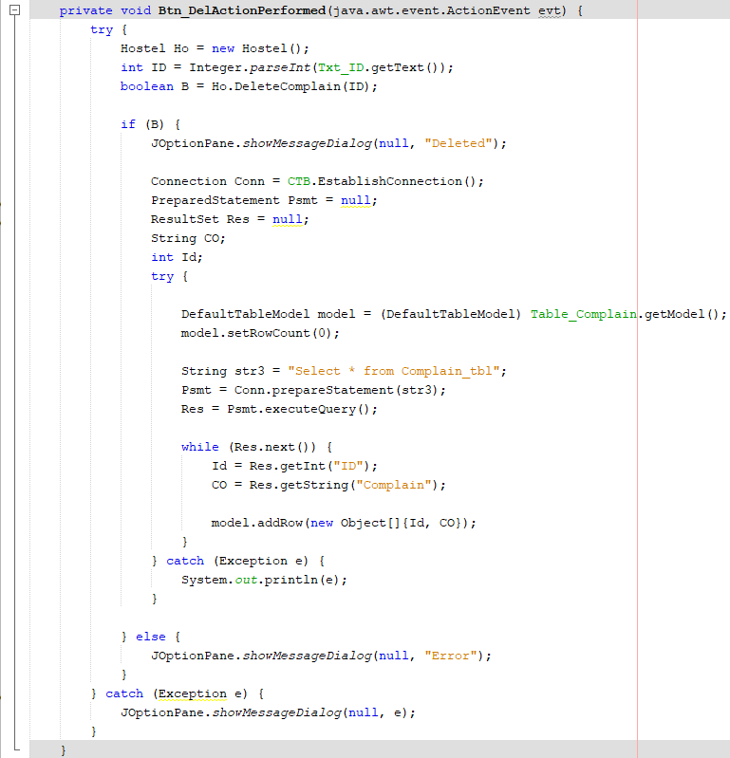

**BACK BUTTON:**

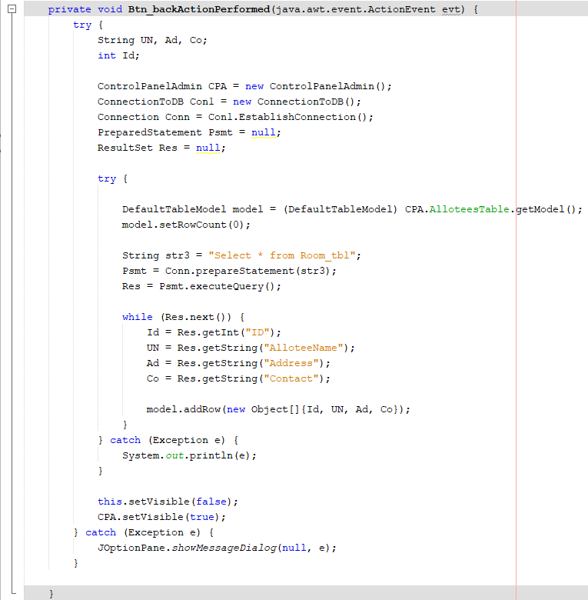

**CONTROL PANNEL ALLOTEE FORM BUTTONS:**

**EDIT BUTTON:**

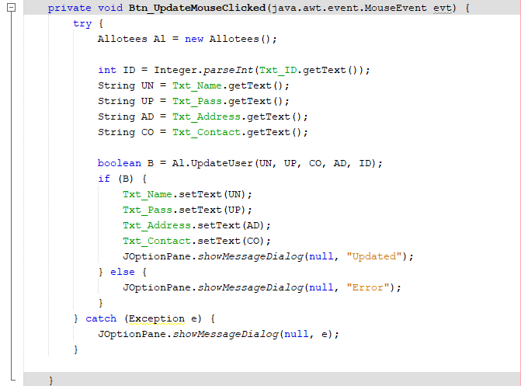

**SUBMIT BUTTON:**

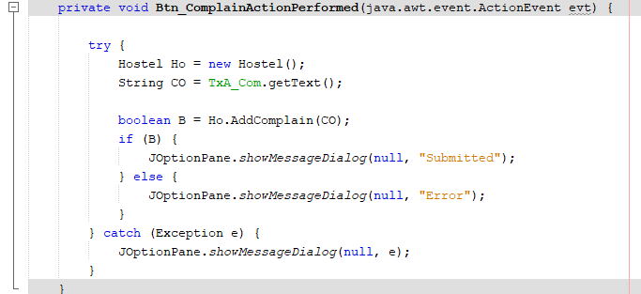

We Have Used This Code In Our Every Form Constructor To Bring Forms In Center Of Window Automatically Whenever The Form Runs.

**CODE:**

**OUTPUTS**

**MAINPAGE:**

**ADMIN LOGIN:**

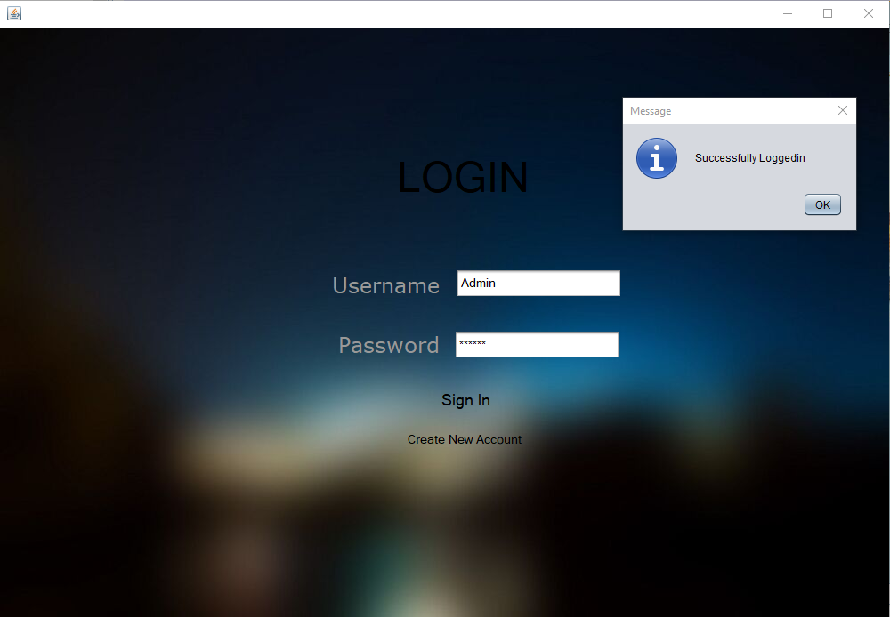

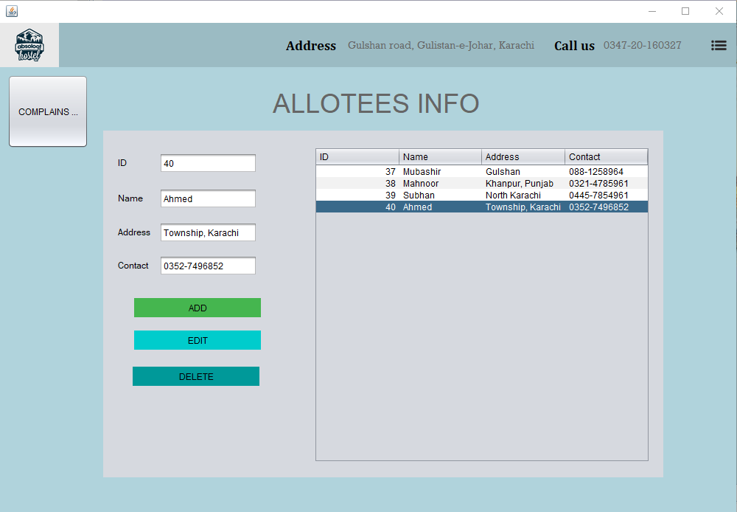

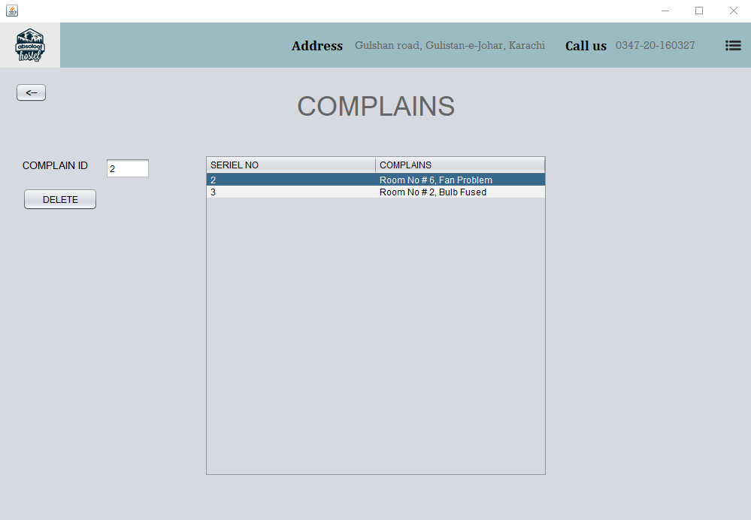

**ALLOTEE LOGIN:**

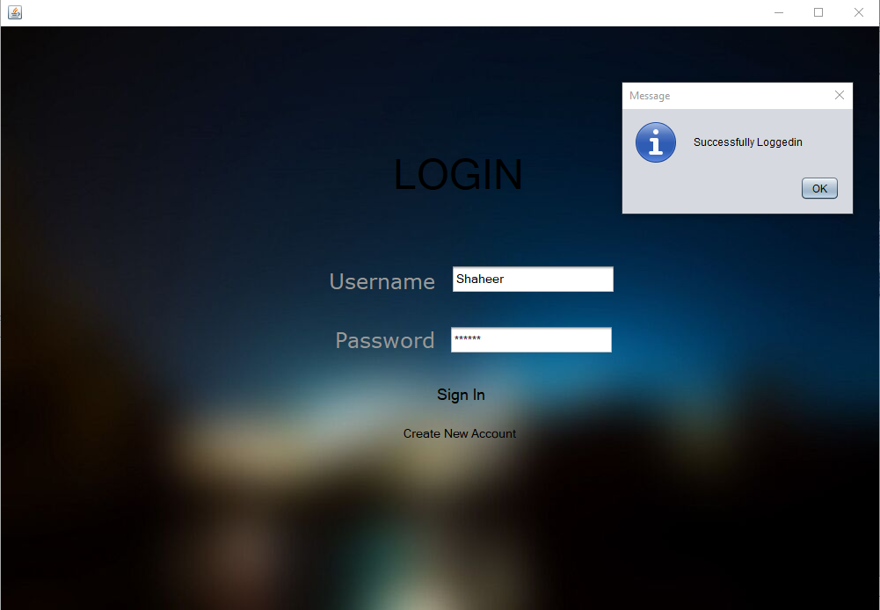

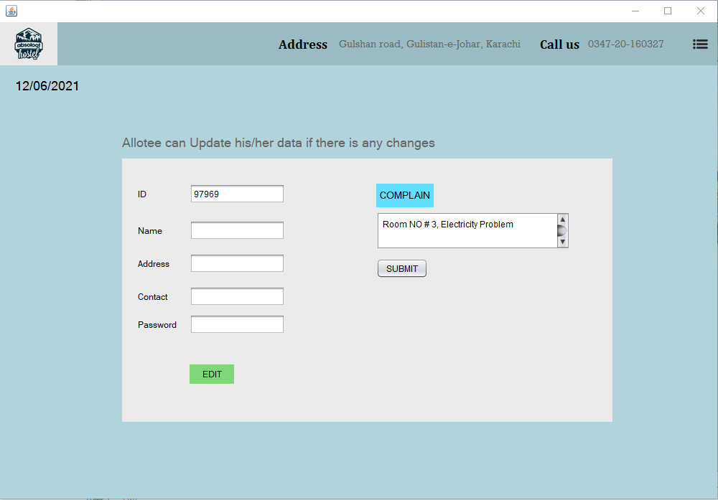

**NEW REGISTRATION:**

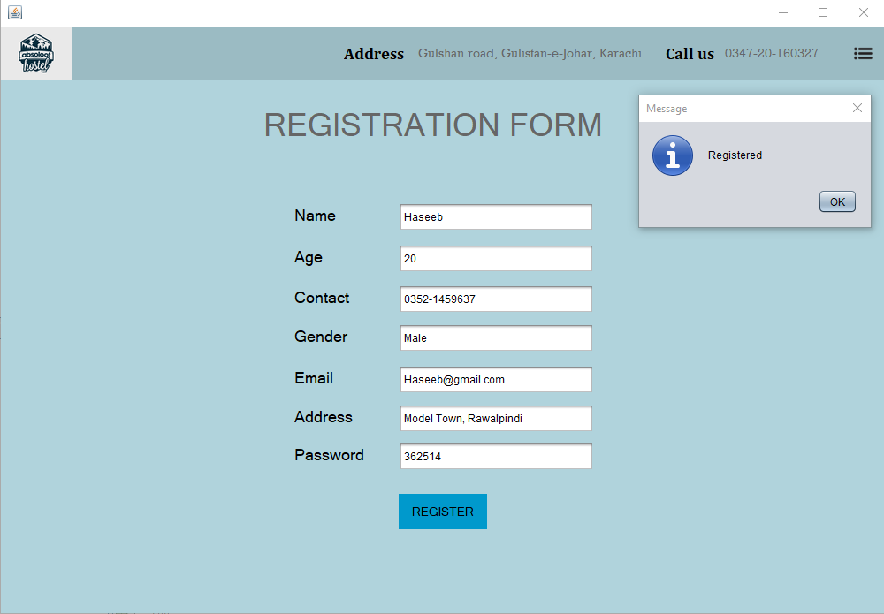

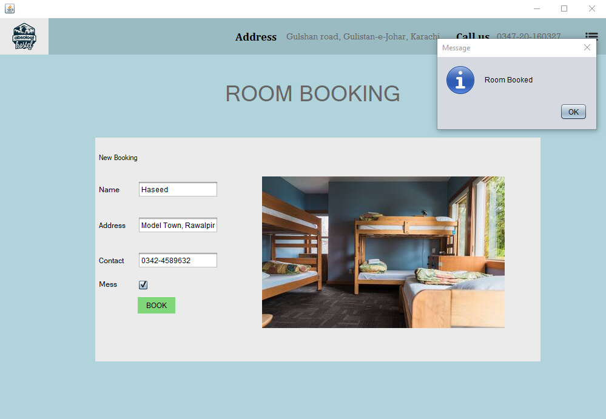

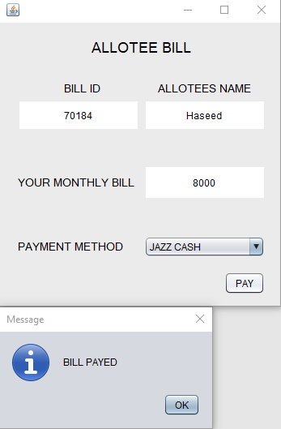

# **HARDWARE SPECIFICATION:**

* PC or Laptop

# **SOFTWARE SPECIFICATION:**

* RAM 4 GB
* ROM 500 GB
* NETBEANS
* JDK
* WINDOWS
* MS Access
* Notepad

# **CONCLUSION**

To conclude; the project, developed using PHP and MySQL is based on the requirement specification of the user and the analysis of the existing system, with flexibility for future enhancement. The expanded functionality of today’s software requires an appropriate approach towards software development. This hostel management software is designed for people who want to manage various activities in the hostel. For the past few years, the number of educational institutions is increasing rapidly. Thereby the number of hostels is also increasing for the accommodation of the students studying in this institution. And hence there is a lot of strain on the person who are running the hostel and software’s are not usually used in this context. This project deals with the problems on managing a hostel and avoids the problems which occur when carried manually. Identification of the drawbacks of the existing system leads to the designing of computerized system that will be compatible to the existing system with the system which is more user friendly and more GUI oriented.

# **REFERENCES**

<https://www.geeksforgeeks.org>

<https://stackoverflow.com>

<https://www.youtube.com/>